# Assignment 2 Report

**Name(s):** Saket Reddy, Aidan Andrews

**NetID(s):** saketr3, aidansa2

In each the following parts, you should insert the following:

* Train/test loss plots
* Qualitative outputs for GT, No encoding, Basic Positional Encoding, and Fourier Feature Encoding

**Part 1: Low resolution example**

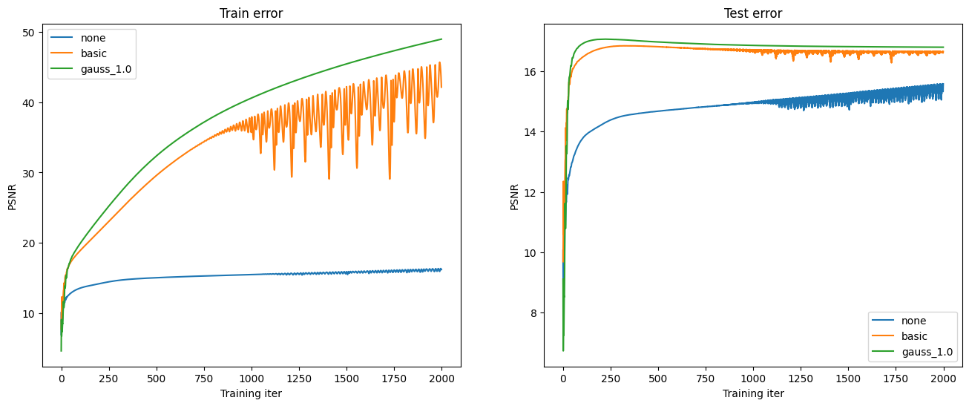

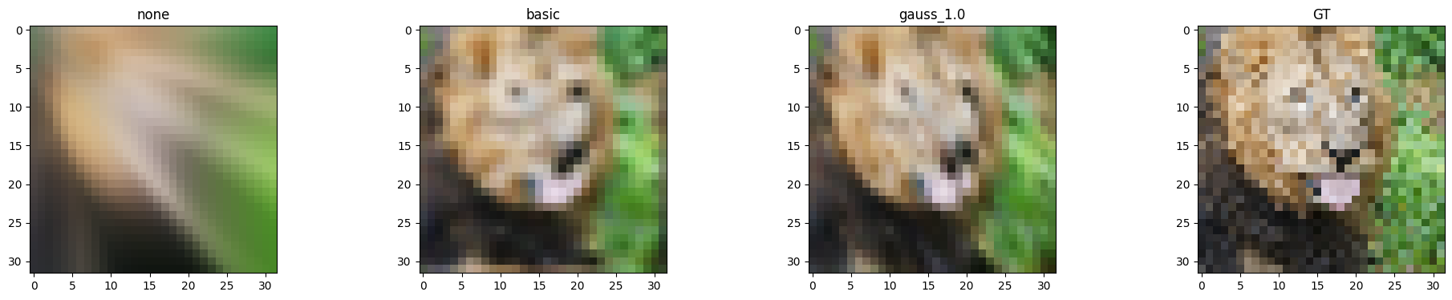

**Part 2: High resolution example**

**Part 3: High resolution (image of your choice)**

*(For this part, you can select an image of your choosing and show the performance of your model with the best hyperparameter settings and mapping functions from Part 2. You do not need to show results for all of the mapping functions.)*

**Part 4: Discussion**

*Briefly describe the hyperparameter settings you tried and any interesting implementation choices you made.*

*How did the different choices for coordinate mappings functions compare?*

*Do you make any interesting observations from the train and test plots?*

*What insights did you gain from your own image example (Part 3)?*

**Part 5: Extra Credit (optional)**

*Explain anything you did in detail and provide output images.*